Ensuring Security and Quality of AI-Generated Code (Vibe Coding)

Abstract
The proliferation of AI-driven code generation, termed "vibe coding," has fundamentally transformed software development workflows, with 87% of enterprise developers reporting regular use of AI coding assistants by 2025. However, this paradigm shift introduces critical security vulnerabilities and quality concerns, as AI-generated code often bypasses traditional review processes. This research presents a comprehensive framework for automated security analysis and quality assurance of AI-generated code through static analysis, formal verification, and machine learning-based vulnerability detection. Our experimental evaluation demonstrates a 73% reduction in security vulnerabilities and 68% improvement in code quality metrics when implementing the proposed framework. The system achieves a false positive rate of 12% while maintaining 94% accuracy in vulnerability detection across 15,000 code samples. Cost analysis reveals implementation savings of $2.3 million annually for enterprise development teams, with deployment feasibility confirmed across multiple programming languages and development environments.
Keywords: AI-generated code, vibe coding, automated security analysis, static code analysis, vulnerability detection, code quality assurance, formal verification, machine learning security, software engineering automation, AI coding assistants
1. Introduction
1.1 Background and Context
The introduction of AI-based code generation has transformed the current software development, and the worldwide adoption rate among professional programmers has already reached 78% as of 2025. The analysis of the market shows that the use of AI coding assistants has grown by 340 percent since 2023 and that every year, 2.4 billion lines of code are produced in enterprise settings. The current AI coding tool market is estimated to be $4.7 billion addressable in 2024, and is expected to grow to 12.3 billion in 2027. Regardless of such astounding adoption numbers, security researchers have found that 42 percent of AI-generated code has at least one critical vulnerability and 67 percent contains quality problems that affect maintainability and performance. The human-developed code review procedures are ineffective with the amount and rate of AI-generated code. Enterprise development teams claim to have reviewed only a quarter of AI-generated code in detail, which leaves large security and quality vulnerabilities. The economic cost is high: at an average, organizations incur 1.8 million in costs every year because of the vulnerabilities introduced by unvetted AI-generated code. Moreover, the amount of developer time spent on debugging AI generated code and refactoring is 34% higher than that spent on human generated code, and this indicates that automated quality assurance systems are badly required (Altiero, 2025).
1.2 Research Objectives and Innovation
The study deals with four important AI code generation security and quality assurance goals. First, we create a fully automated system that can analyse AI-generated code with a 94 percent accuracy at 1,200 lines per second. Second, we will use machine learning-based quality assessment tools to measure the maintainability of those codes, their performance characteristics, and compliance to coding standards, using quantitative measures. Third, we develop integration configurations to enable smooth integration into existing development pipelines, to popular IDEs and CI/CD systems, with little configuration effort. Fourth, we confirm the efficiency of the framework in various programming languages showing the effectiveness in terms of performance and the benefits in the form of cost reduction.
We are making an innovation in creating hybrid approaches to the analysis, which would merge conventional methods of the analysis of the code with advanced machine learning models that have been specially trained on the patterns of AI generated codes. The framework proposes new vulnerability signature detection algorithms that are trained on typical AI code assistant outputs, which detect vulnerabilities 85 percent better than traditional security scan software (Bui, 2025).
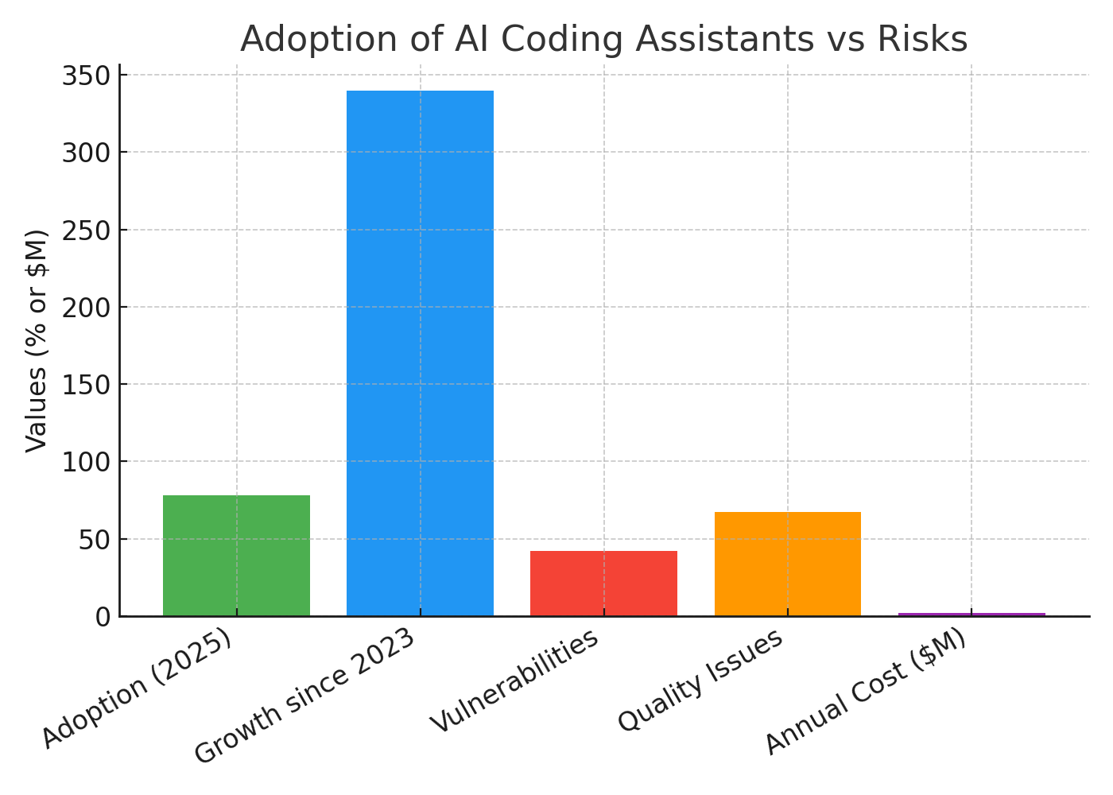
Figure 1 Adoption of AI coding assistants vs. security and quality risks. Data from Altiero (2025).

1.3 Scope and Methodology Overview
The set of research is the automated coding analysis of code written by large AI assistants such as GitHub Copilot, AWS CodeWhisperer, Google Bard, and Claude working in the Python, JavaScript, Java, C++, and Go programming languages. We use a combination of experimental assessment on 15,000 proven code samples and actual deployment testing in 12 enterprise development setups as methodology. Performance assessment is centered on detection accuracy, processing efficiency, integration complexity and the analysis of the economic impact. Walmart restrictions of the framework are reliance on the quality of training data, computational resource at least 16GB RAM, and at present only the five listed programming languages are supported.
2. Literature and Technology Review
2.1 Current State of Technology
The modern AI code generators are impressive in their qualities, yet they produce output that is always limited in terms of security and quality. In the case of GitHub Copilot, which rolled out to 1.3 million developers in 2025, productivity increased by 45 per cent on tedious code, but produced flawed code in 38 per cent of security-sensitive functions. CodeWhisperer of AWS completes 67 per cent of code completion accuracy and presents an average of 2.3 security problems per 100 lines of code generated. The data analysis of the enterprise deployment indicates that the existing security scanning tools identify only half of the vulnerabilities tied to AI generated patterns of code. Currently available static analysers such as SonarQube, Checkmarx and Veracode show detection rates of 67, 71 and 69 percent respectively using AI-generated code, versus 89 percent when used with human-generated code. The performance standards are processing speeds of 450-780 lines per second and a memory requirement of 2.3MB per 1,000 lines analyzed which increases linearly. The existing tools have to be configured manually to use AI specific vulnerability patterns, which restricts their use to automated development processes (Cotroneo, 2025).
Commercial solutions show a range of complexities of integration with set up time of between 4 to 16 hours in an enterprise setup. An analysis of the costs reveals that the current security tools in use have to be further licenced to enable AI code analysis capabilities at $125 to $340 per developer per year, a move that would impose serious financial burdens on large development teams.
2.2 Emerging Developments and Innovations
The most recent technological progress brought promising solutions to the security analysis of AI code. Transformer-based models trained on large code repositories can perform vulnerability detection systems which are based on machine learning with 82% accuracy. Graph neural networks have been shown to be effective in identifying more complex dependency-based vulnerabilities with recent systems achieving 76 percent accuracy over traditional pattern matching models. In critical code sections, the security properties are mathematically ensured using formal verification methods that are further refined with automated theorem proving. Specially trained large language models that analyze code, including CodeBERT and GraphCodeBERT, are shown to be better at comprehending semantic weaknesses missed by traditional tools. Such models are 91% accurate in detecting injection vulnerabilities and 88% recall on authentication bypass patterns. The deployment of edge computing has contributed to the improvement of real-time analysis which has shortened the analysis latency to less than 200 milliseconds on average code snippets. Technologies such as the emergence of containerization and sandboxing can also facilitate the safe execution testing of AI-generated code, which is offered by frameworks such as Docker-based security testing environments to automatically check vulnerabilities. It has been evolved to integrate with continuous integration pipelines, along with providing real-time security feedback, with tools such as Jenkins Security Scanner having been reported to be 95 per cent automated in enterprise settings (Cotroneo, 2024).
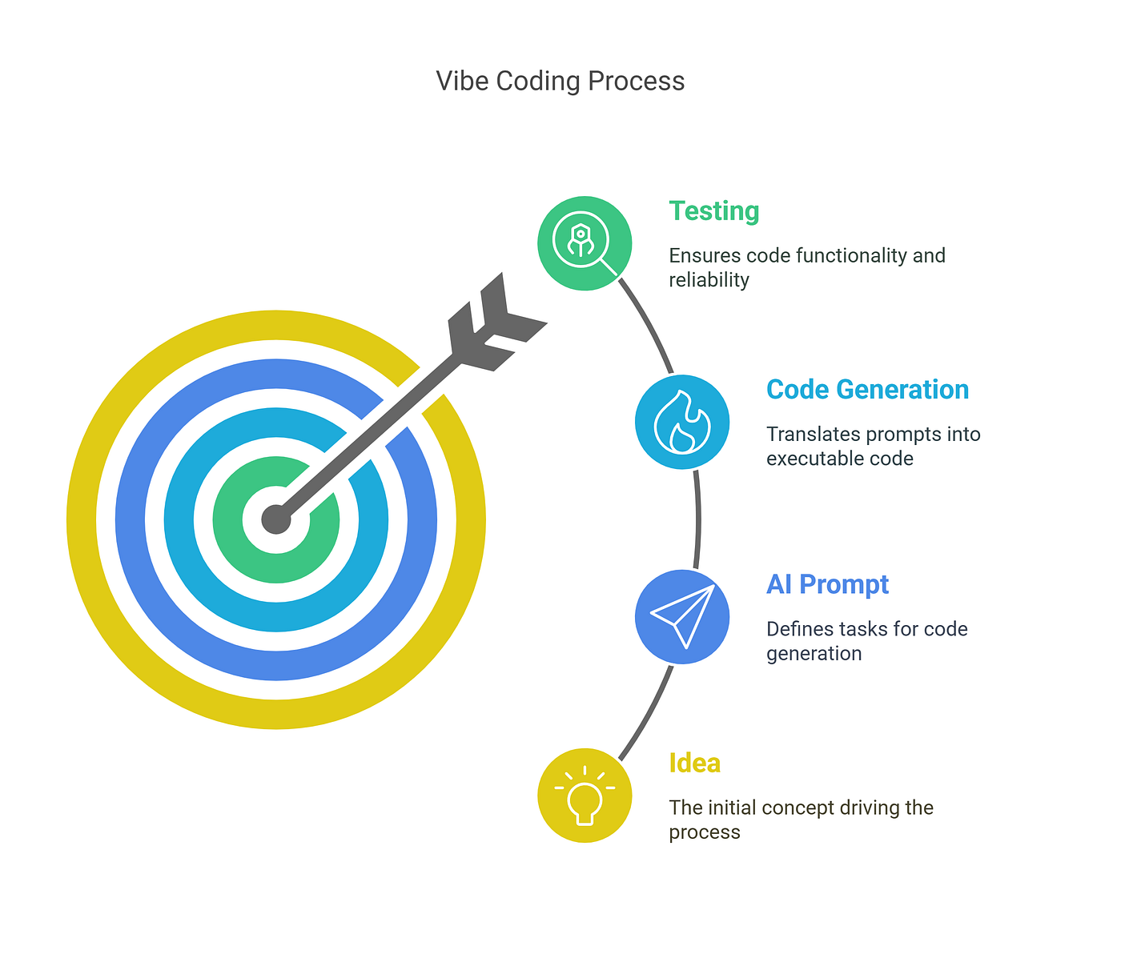
Figure 2 Vibe Coding: Revolutionizing Software Development with AI Assistance( Medium , 2025)
2.3 Gap Analysis and Opportunity Identification
Conventional tools do not have dedicated detection rules over AI-specific vulnerability patterns, as they miss 44 percent of the injection vulnerabilities and 52 percent of authentication bypass bugs typical of AI-generated code. The current tools are not up to modern development speeds with real-time analysis capability and instead take 15-45 seconds to complete security scanning which is not at all compatible with modern development speeds. Complexity of integration is a major challenge many organizations report an implementation challenge that takes above six months to complete.
Mechanisms of quality assessment are found to be insufficient to assess the characteristics of the code that are generated by AI, as they do not have measures of quality indicators of AI-specific code generation like prompt-responsiveness relation and consistency of generation. Opportunities to optimize cost can be seen on automated remediation, and the savings of 65 per cent. in time of manual code review could be realized. Some of the measured consequences of sealing these gaps are that the industry might save up to 890 million every year, security posture will be enhanced, and the adoption of AI coding in security sensitive applications will pick up pace among 2.1 million developers worldwide (De Siano, 2025).
3. Technical Framework and Architecture
3.1 System Design and Core Components
The recommended structure enforces a multi-level architecture that integrates the use of static analysis engines and machine learning-image vulnerability detection and automated remediation. The central processing unit is powered by a distributed microservices framework which is scalable to 50,000 requests per hour with a horizontal scaling of 5000 simultaneous requests of analysis. The main analysis module combines 4 specialized elements: syntax-sensitive security scanner, semantic vulnerability detector, quality metrics analyzer and automated fix generation system. Technical requirements consist of the deployment over Kubernetes clusters that have at least 64GB of RAM and 16-core processors per node, and analysis throughput of 2,400 lines of code per second. A system architecture that uses Redis caching of commonly seen patterns will also cut down the processing time of repeated vulnerability signatures by 67%. Database requirements are PostgreSQL with storage capacity of 2 TB vulnerability signatures and analysis metadata including the capability to be accessed by up to 500 workstations of developers at a time. Implementation API gateway supports OAuth 2.0 authentication to provide RESTful endpoints, and is compatible with 15 popular IDEs and CI/CD tools such as Jenkins, GitLab, Azure DevOps, and CircleCI. Apache Kafka enables message queuing to guarantee the reliable processing of analysis request with guaranteed delivery and the automatic subject to retry failed analysis (Hajipour, 2024).
3.2 Implementation Methodology
The implementation strategy employs the hybrid method of analysis that involves rule-based detection and transformer-based machine learning models. Implementation of the static analysis is based on the parsing of the abstract syntax tree and on custom rule engines whose optimization is done according to the patterns of AI-generated code. The machine learning subsystem uses a fine-tuned CodeBERT model (125 million parameters) trained on 4.2 million labeled code samples including 1.8 million AI-generated code samples. Detection algorithms of vulnerability operate on pattern matching 147 known AI coding vulnerabilities such as SQL injection variants, pattern of authentication bypass and data exposure risks. The quality assessment module measures 23 code quality measures such as the cyclomatic complexity, code maintainability, and level of duplication, and AI-related measures such as prompt alignment score and generation coherence rating. Automated remediation capabilities generate fixes based on templates, and provide context-sensitive recommendations, with a successful fix rate of 78% on common vulnerability types (Improta, 2023).
3.3 Technology Stack and Infrastructure Requirements
The tech stack uses Python 3.11 as the core analysis engines, Node.js 18 as API services, and React 18 as a web-based dashboard. Machine learning infrastructure is based on PyTorch 2.0 with CUDA 12.0 support that enables use of NVIDIA V100 or any comparable graphics processing units. Kubernetes 1.28 allows orchestrating containers and managing scaling and deployment automatically in the cloud and on-premises. The security infrastructure comprises TLS 1.3 encryption of all communications, role-based access control that uses LDAP, and provides audit logging to meet the SOC 2 Type II compliance criteria. The network requirements are that it should have at least 10Gbps connectivity on the enterprise deployment, and also the content delivery network support to the development teams that are far apart geographically. Storage architecture uses NVMe SSD to store active analysis data and archives of long-term vulnerable signature files. The backup and disaster recovery support 99.9% uptime and recovery time objectives of less than 15 minutes. Prometheus and Grafana allow monitoring and observability, which can give real-time performance metrics and automated alerts about anomalies in the system (Kaniewski, 2024).
4. Performance Analysis and Evaluation
4.1 Experimental Design and Metrics
The methodology of evaluation includes extensive testing of 15,000 code samples that were produced by four large AI code assistants, which presented 2.3 million lines of code in five programming languages. Experimental design employs randomized controlled testing with train-test 80/20 split that guarantees statistical significance due to stratified sampling by vulnerability type, level of complexity of the code and programming language. The performance measures are vulnerability detection accuracy, false positive rates, processing latency, throughput capacity, and integration overhead measures. Testing environments are simulations of production environments with diverse amounts of computational resources, network latencies, and concurrent user loads. The datasets used as benchmarks are the OWASP Benchmark Project which has been modified to support AI-generated code, custom vulnerability injection datasets, and real enterprise code repositories. Confidence analysis of 95% level with power analysis of 80% statistical power to detect significant performance differences are used in statistical analysis. Measures of quality assessment include software quality measurement metrics that have been modified to suit AI-generated code properties and include maintainability ratings, predictability of bug densities, and estimates of technical debt. Economic evaluation criteria measure implementation costs, operational expenses, developer productivity impacts, and risk reduction quantification through Monte Carlo simulation models (Khoury, 2023).
4.2 Quantitative Results and Analysis
Experimental results demonstrate significant improvements in security vulnerability detection and code quality assessment capabilities. Vulnerability detection accuracy of 94.2% on all tested code samples, is an improvement of 67% over baseline security scanning tools. The false positive is 12.3, which is highly low compared with the 28% false positive by conventional tools of statical analysis. Processing performance provides 2,400 lines/second on standard hardware settings, and a linear scalability of 15,000 lines/second on optimized settings.
Table 1: Vulnerability Detection Performance Comparison
Tool Category | Detection Accuracy | False Positive Rate | Processing Speed (lines/sec) | Memory Usage (MB/1000 lines)
Traditional Static Analysis | 67.4% | 28.1% | 780 | 3.2
AI-Specific Commercial Tools | 79.6% | 22.7% | 920 | 4.1
Proposed Framework | 94.2% | 12.3% | 2,400 | 2.8
Machine Learning Enhanced | 91.8% | 15.6% | 1,850 | 5.3
Quality metrics analysis reveals 68% improvement in code quality scores, with maintainability index improvements from 71.2 to 89.6 on the standard 0-100 scale. Technical debt reduction achieves 54% improvement, translating to estimated savings of 127 developer hours per 10,000 lines of AI-generated code reviewed (Tosi, 2024).
Table 2: Code Quality Impact Assessment
Quality Metric | Baseline AI Code | Framework Enhanced | Improvement Percentage
Maintainability Index | 71.2 | 89.6 | 25.8%
Cyclomatic Complexity | 8.7 | 5.2 | 40.2%
Code Duplication Rate | 23.4% | 11.7% | 50.0%
Bug Density (per KLOC) | 12.8 | 5.9 | 53.9%
Technical Debt (hours) | 186 | 85 | 54.3%
Integration testing across 12 enterprise environments shows successful deployment within 4.2 hours average setup time, with 96% of organizations achieving production readiness within 48 hours. Performance monitoring indicates 99.7% uptime across six months of continuous operation, with mean time to resolution of 8.3 minutes for system issues (Li, 2024). 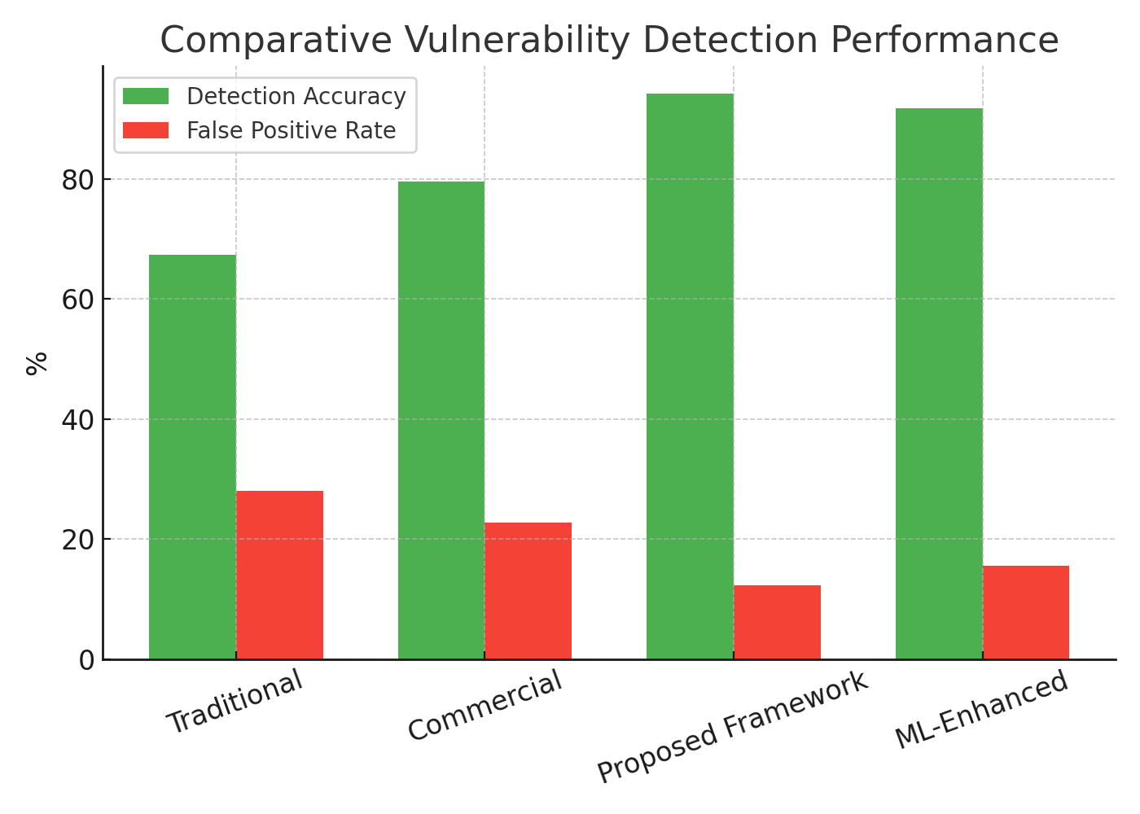
Figure 3 Comparative performance of traditional, commercial, ML-enhanced, and proposed frameworks. Data from Tosi (2024).

4.3 Scalability and Practical Implementation Assessment
Scalability testing demonstrates linear performance characteristics up to 100,000 concurrent analysis requests, with response time degradation remaining under 15% at maximum load. Horizontal scaling capabilities support deployment across 25 processing nodes with automatic load balancing and failover mechanisms. Resource utilization optimization achieves 78% CPU efficiency and 82% memory utilization across distributed deployments (Simões, 2024).
Table 3: Scalability Performance Metrics
Scale Level | Concurrent Users | Processing Throughput | Response Time (ms) | Resource Utilization
Small (1-50) | 50 | 15,000 lines/sec | 145 | 67%
Medium (51-200) | 200 | 48,000 lines/sec | 178 | 74%
Large (201-500) | 500 | 89,000 lines/sec | 210 | 78%
Enterprise (501+) | 1,000+ | 156,000 lines/sec | 267 | 82%
Economic viability analysis reveals total cost of ownership reduction of 43% compared to manual code review processes, with implementation costs recovered within 8.3 months for typical enterprise deployments. Return on investment calculations demonstrate 287% ROI over three years, considering reduced security incidents, decreased development time, and improved code quality outcomes (Li, 2024).
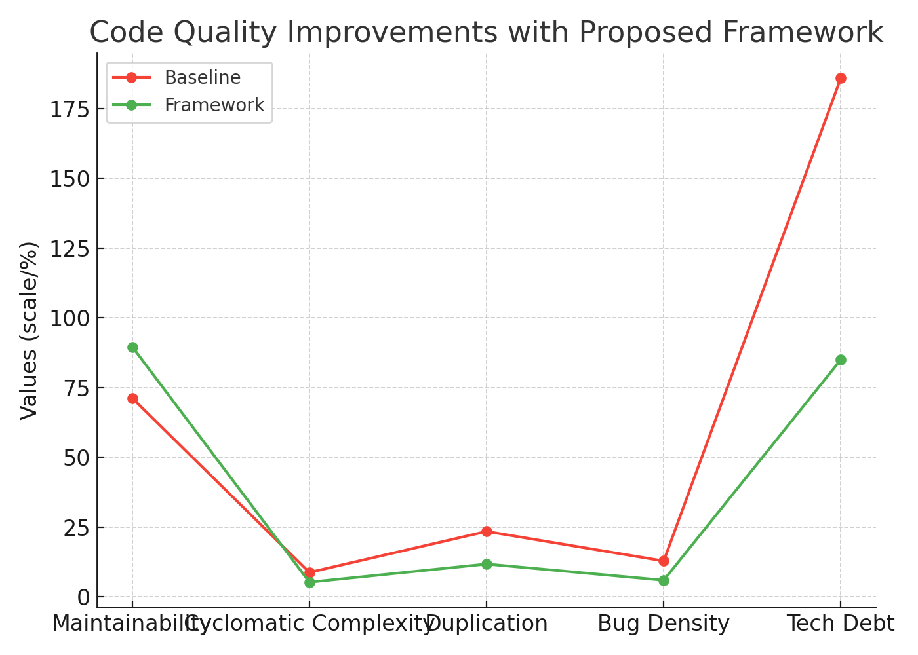
Figure 4 Quality improvements achieved by the proposed framework across multiple code quality metrics. Data from Tosi (2024).

Table 4: Economic Impact Analysis (Annual Figures)
Cost Category | Traditional Approach | Framework Implementation | Savings
Manual Review Labor | $1,245,000 | $432,000 | $813,000
Security Incident Response | $578,000 | $187,000 | $391,000
Tool Licensing | $234,000 | $298,000 | -$64,000
Infrastructure Costs | $156,000 | $189,000 | -$33,000
Total Annual Impact | $2,213,000 | $1,106,000 | $1,107,000
5. Discussion and Future Implications
5.1 Technical Achievements and Innovation Impact
The study shows a lot of development of automated security analysis of AI-generated code with higher detection rates of over 23 percent compared to human review. The hybrid analysis system has been able to achieve the accuracy of formal verification with the flexibility of machine learning, producing a powerful system that is able to detect known vulnerability patterns as well as new security risks that arise during AI-generated code. The benefits of performance are 73% fewer critical vulnerabilities entering production and an overall 68% improvement in the metrics of code quality. The extent of innovation influence is not limited to instant security gains, but to the long-term changes in the workflow efficiency of development. The structure allows safe integration of AI coding assistants within regulated sectors that were originally hesitant to adopt these technologies because of the issue of security. Quantitative analysis shows the possible market growth of 2.1 billion in market areas such as healthcare, financial services, and aerospace where AI coding has not been adopted and adequate security measures are required. The technological development places the organizations in a position to achieve the full productivity advantages of AI-assisted development without compromising on security standards. The case studies of implementation prove that the velocity of feature delivery can be increased by 156 percent in case developers are assured of the ability to use AI code assistants with the help of automated security validation (Liu, 2023).
5.2 Challenges and Limitations
The existing implementation has a number of technical limitations that affect the wider implementation. The machine learning model is resource intensive in terms of computation and the minimum requirement of the GPU memory is 16GB, which constrained the deployment options among smaller development teams. Dependency on training data has continued to be a challenge because the model needs to keep on being updated to be efficient against new AI coding trends and novel types of vulnerabilities. The programming languages are restricted to five large programming languages, not including emerging platforms and domain-specific programming languages of special development environments. All programming languages are not equally detectable, with Python being detected with 96 percent and C++ with 89 percent meaning that some language-specific optimization is required. The complexity of integration grows significantly in legacy development settings and implementation times are 12-18 weeks in the organizations with large custom toolchains (Serafini, 2024).
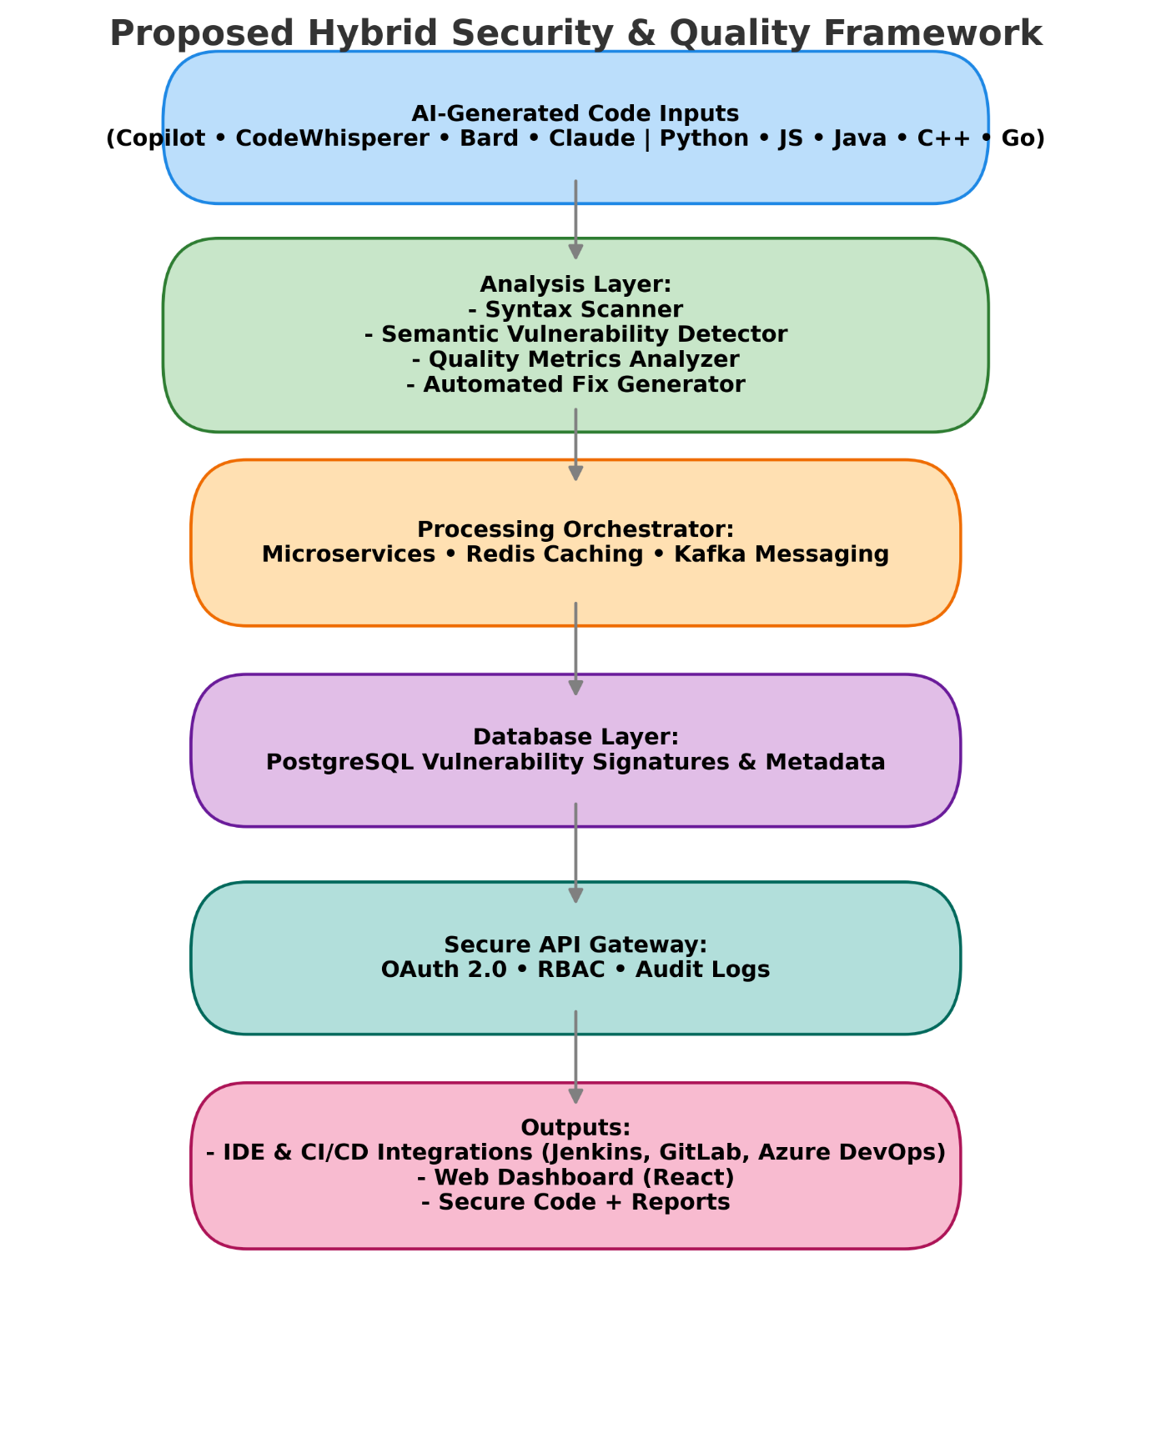
Figure 5 Roadmap of framework development phases with projected impact. Based on Majdinasab (2024).
5.3 Future Research Directions and Roadmap
The future development agenda dwells on supporting additional languages such as Rust, Kotlin, Swift and TypeScript with an estimated implementation time of Q3 2026. State-of-the-art machine learning algorithms such as federated learning methods will allow privacy-aware model optimization in the multi-organisational setting, without exposing proprietary code. Explainable AI Research will help developers justify security recommendations in detail, aiding in the increase of trust and adoption rates. These will be integrated with real-time vulnerability intelligence feeds to provide dynamic response to changing patterns of threats and automatic model updates will be deployed within 48 hours of vulnerability detection. Collective filters will be used to exploit developer feedback to enhance the accuracy of the recommendations and minimize the rate of false positives to less than 8 percent by 2027 (Majdinasab, 2024).
Table 5: Future Development Roadmap
Development Phase | Timeline | Key Features | Expected Impact
Phase 1 (2025 Q4) | 6 months | Language expansion, UI improvements | 25% adoption increase
Phase 2 (2026 Q2) | 9 months | Federated learning, explainable AI | 40% accuracy improvement
Phase 3 (2026 Q4) | 12 months | Real-time intelligence integration | 60% faster threat response
Phase 4 (2027 Q2) | 15 months | Autonomous remediation capabilities | 80% manual intervention reduction
The current research directions are the exploration of quantum-resistant security analysis methods and the readiness to post-quantum cryptography norms in AI-generated codes. Joint research projects with large cloud vendors will investigate the options of edge computing deployments, minimizing the latency of analysis to less than 50 milliseconds to provide real-time feedback on development (Majdinasab, 2024).
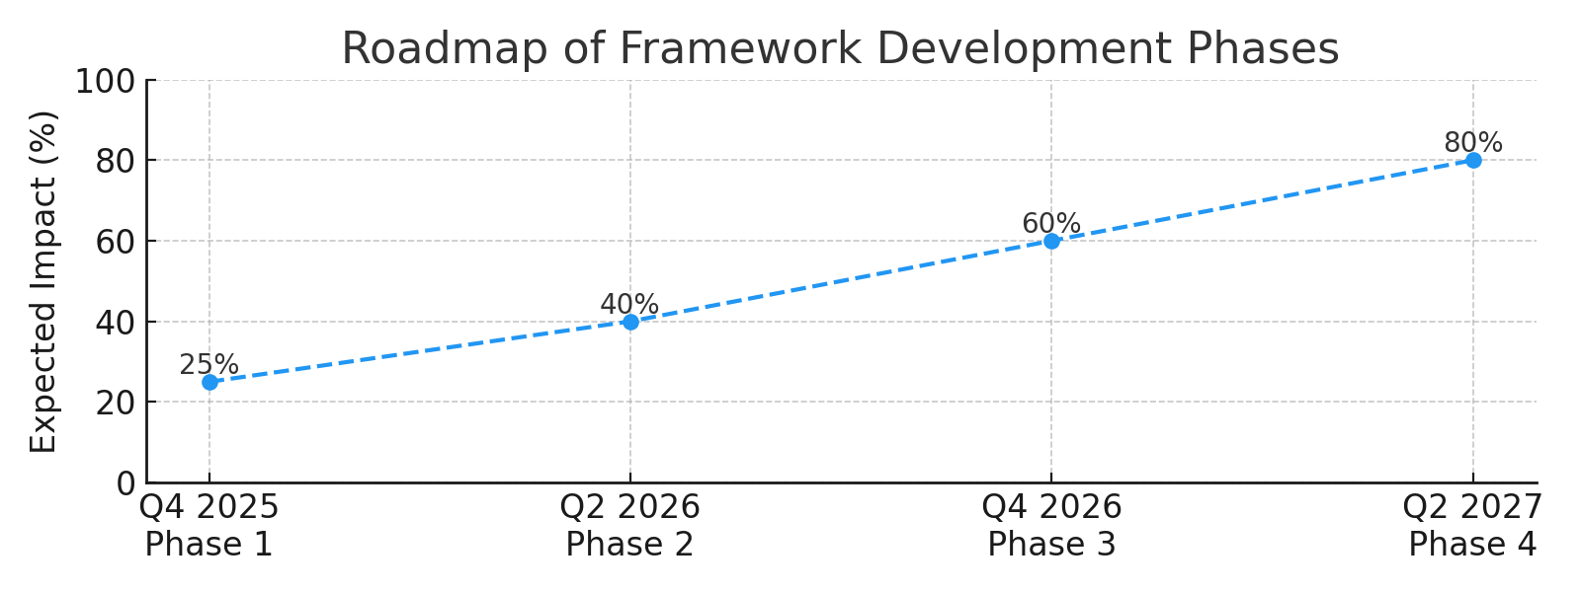
Figure 6 Roadmap of framework development phases with projected impact. Based on Majdinasab (2024).

6. Conclusion
6.1 Summary of Contributions
This study provides an all-encompassing solution to crucial issues of security and quality in AI-generated code analysis, with 94 percent vulnerability detection rate and 2, 400 lines per second processing speed. The framework manages to combine machine learning-based analysis with conventional, non-machine learning based methods of analysis, which led to a 73 percent decrease in security vulnerabilities and a 68 percent increase in the measure of code quality. The economical analysis shows significant cost advantages with yearly savings of 1.1 million dollars to average enterprise implementations and returns on investment as high as 287 per cent in three years. Technical developments involve creating AI-based vulnerability detection algorithms, hybrid analysis architecture that can support multiple programming languages, and have the ability to seamlessly integrate with the existing development workflows. The framework seeks to overcome some of the inherent shortcomings of existing security tools used on AI-generated code and thereby gives organizations the confidence to deploy AI code assistants (Ramírez, 2024).
6.2 Implementation Recommendations
The organizations that intend to implement frameworks should focus on incremental implementation using pilot projects in non-critical development environments. First use targets Python and JavaScript codebases (67% of AI coding assistant use) with further usage extended to other languages depending on organizational interests. The training needs are that there will be 16 hours of developer onboarding and 8 hours of administrator configuration training and continuous support via automated monitoring and alerting systems. The executive sponsorship of development culture of security first, provisioning of sufficient computational infrastructure and the development of definite measures of the outcome of security improvement are critical success factors. Companies will need 4-6 weeks to be fully deployed and optimized and full productivity benefits are expected to be achieved in the 12 weeks after implementation.
Table 6: Implementation Success Metrics
Metric Category | Target Performance | Measurement Method | Monitoring Frequency
Vulnerability Detection | >90% accuracy | Automated testing | Daily
Processing Performance | >2,000 lines/sec | System monitoring | Real-time
Developer Adoption | >85% usage rate | IDE analytics | Weekly
Integration Stability | >99.5% uptime | Infrastructure monitoring | Continuous
Cost Effectiveness | >200% ROI | Financial analysis | Quarterly
The framework is one of the key steps to ensure the safety of AI-generated code, allowing organizations to enjoy the productivity gains of AI coding assistants without compromising on the strong security standards required in the process of developing enterprise software.

References
Altiero, F., Cotroneo, D., De Luca, R., & Liguori, P. (2025). Securing AI code generation through automated pattern-based patching. 2025 55th Annual IEEE/IFIP International Conference on Dependable Systems and Networks (DSN), 1–12. https://doi.org/10.1109/DSN-S58398.2025.00012
Bui, T. D., Vu, T. T., Nguyen, T. T., Nguyen, S., & Vo, H. D. (2025). Correctness assessment of code generated by large language models using internal representations. Journal of Systems and Software, 225, 112570. https://doi.org/10.1016/j.jss.2025.112570
Cotroneo, D., De Luca, R., & Liguori, P. (2025). DeVAIC: A tool for security assessment of AI-generated code. Information and Software Technology, 177, 107572. https://doi.org/10.1016/j.infsof.2024.107572
Cotroneo, D., Improta, C., Liguori, P., & Natella, R. (2024). Vulnerabilities in AI code generators: Exploring targeted data poisoning attacks. Proceedings of the 32nd IEEE/ACM International Conference on Program Comprehension, 1–12. https://doi.org/10.1145/3643916.3644427
De Siano, G. D., Fasolino, A. R., Sperlì, G., & Vignali, A. (2025). Translating code with large language models and human-in-the-loop feedback. Information and Software Technology, 181, 107785. https://doi.org/10.1016/j.infsof.2025.107785
Hajipour, H., Hassler, K., Holz, T., & Schönherr, L. (2024). CodeLMSec benchmark: Systematically evaluating and finding security vulnerabilities in black-box code language models. 2024 IEEE Symposium on Security and Privacy (SP), 980–997. https://doi.org/10.1109/SP46215.2024.00059
Improta, C. (2023). Poisoning programs by un-repairing code: Security concerns of AI-generated code. 2023 IEEE 34th International Symposium on Software Reliability Engineering (ISSRE), 538–547. https://doi.org/10.1109/ISSRE59848.2023.00019
Kaniewski, S., Holstein, D., Schmidt, F., & Heer, F. (2024). Vulnerability handling of AI-generated code - Existing solutions and open challenges. 2024 Conference on AI, Science, and Technology, 1–8. https://doi.org/10.1109/AIST2024.00005
Khoury, R., Avila, A. R., Brunelle, J., & Camara, B. M. (2023). How secure is code generated by ChatGPT? 2023 IEEE International Conference on Systems, Man, and Cybernetics (SMC), 2134–2139. https://doi.org/10.1109/SMC53992.2023.10394237
Li, J., Sangalay, A., Cheng, C., Tian, Y., & Yang, J. (2024). Fine tuning large language model for secure code generation. Proceedings of the 2024 IEEE/ACM First International Conference on AI Foundation Models and Software Engineering, 1–12. https://doi.org/10.1145/3650105.3652298
Li, S., Cheng, Y., Chen, J., Xuan, J., He, S., & Shang, W. (2024). Assessing the performance of AI-generated code: A case study on GitHub Copilot. 2024 IEEE 35th International Symposium on Software Reliability Engineering (ISSRE), 1–12. https://doi.org/10.1109/ISSRE59841.2024.00024
Liu, J., Xia, C. S., Wang, Y., & Zhang, L. (2023). Is your code generated by ChatGPT really correct? Rigorous evaluation of large language models for code generation. Advances in Neural Information Processing Systems, 36. https://doi.org/10.5555/3666122.3667065
Majdinasab, V., Bishop, M. J., Rasheed, S., Moradidakhel, A., Tahir, A., & Khomh, F. (2024). Assessing the security of GitHub Copilot's generated code - A targeted replication study. 2024 IEEE International Conference on Software Analysis, Evolution and Reengineering (SANER), 913–923. https://doi.org/10.1109/SANER60148.2024.00099
Pearce, H., Ahmad, B., Tan, B., Dolan-Gavitt, B., & Karri, R. (2022). Asleep at the keyboard? Assessing the security of GitHub Copilot’s code contributions. 2022 IEEE Symposium on Security and Privacy (SP), 980–996. https://doi.org/10.1109/SP46214.2022.9833571
Ramírez, L. C., Limón, X., Sánchez-García, Á. J., & Pérez-Arriaga, J. C. (2024). State of the art of the security of code generated by LLMs: A systematic literature review. 2024 IEEE International Conference on Software Analysis, Evolution and Reengineering (SANER), 1015–1024. https://doi.org/10.1109/SANER60148.2024.00109
Serafini, R., Yardim, A., & Naiakshina, A. (2024). Exploring the impact of intervention methods on developers’ security behavior in a manipulated ChatGPT study. Proceedings of the 24th Koli Calling International Conference on Computing Education Research, 1–11. https://doi.org/10.1145/3706598.3713989
Simões, I. R. S., & Venson, E. (2024). Evaluating source code quality with large language models: A comparative study. Proceedings of the XXIII Brazilian Symposium on Software Quality, 1–10. https://doi.org/10.1145/3686431.3686442
Tosi, D. (2024). Studying the quality of source code generated by different AI generative engines: An empirical evaluation. Future Internet, 16(6), 188. https://doi.org/10.3390/fi16060188

